MicroplateGR2 Version 2.1: Software to process microbial growth kinetics from microtiter plate data.

Figure 1. MicroplateGR2 main screen

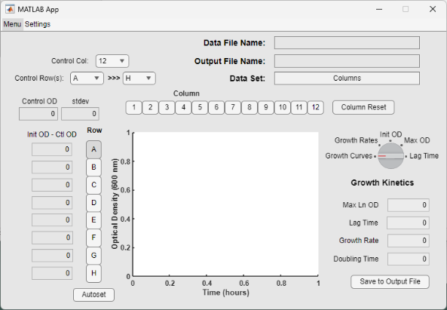Microtiter plate readers offer a convenient means of determining microbial growth parameters, but the commonly used methodology has been found to be subject to systematic errors, principally based on initial cell concentration (Atoli et al., 2020; Begot et al., 1996). The MicroplateGR2 software (shown in Figure 1) package was developed to allow users to accurately estimate microbial growth kinetics values and understand the factors influencing accuracy and the sources of error growth.

Input data is formatted in the form of a comma delimited spreadsheet (.csv). This is a common format available from most microtiter plate readers. To take advantage of the features of MicroplateGR2, it is important to inoculate replicate treatments and controls in the microtiter plate in a column format with serial dilutions of the initial cell concentrations (Figure 2).

Figure 2: Plate inoculation scheme for a 96 well microtiter plate

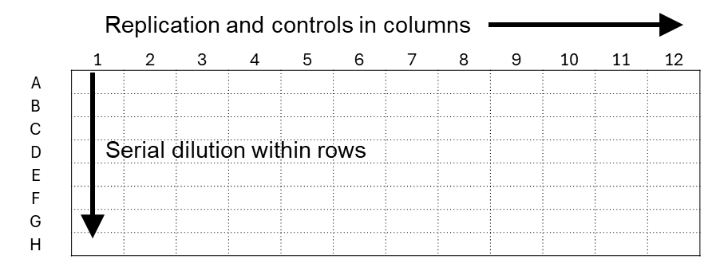

Figure 2. Microtiter plate setup scheme. Up to 12 treatments/replications and controls are in columns, Each treatment then has serial dilutions by row, decreasing cell concentration by a factor of 2 from Row A-H of the microtiter plate.

Using the dilution scheme for preparing the microtiter plate allows the effects of initial cell concentration on growth parameters to be determined. The expected format of the input file required is shown in Figure 3.

Figure 3. Input data format

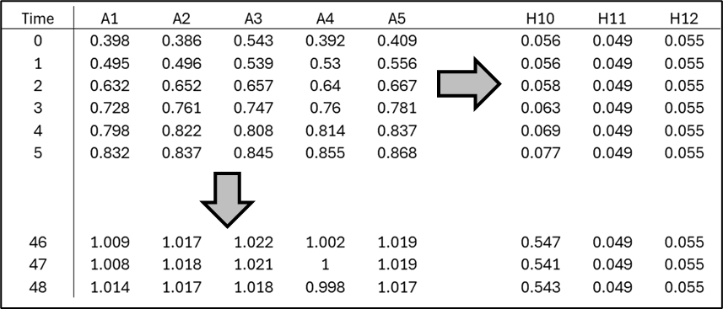

Figure 3. Microtiter plate data format. Data is imported into MicroplateGR2 in a comma delimited spreadsheet, formatted in columns as shown, with a row having 96 data-points (one per column) for each time of sampling. The time units and frequency of sampling may be determined by the user. The example shows readings taken once an hour for 48 hours.

The number of time-points and frequency of sampling are selected by the user, so the length and values of the first column may therefore vary with the experimental conditions. Upon opening the file (Menu > Open MP Data File) a pop-up graph showing all 96 growth curves in displayed (Figure 4).

Figure 4. Pop-up graph showing growth curves

Figure 4. Pop-up graph showing 96 growth curves and control columns for the microtiter plate spreadsheet data.

The graph may be useful for referencing which columns have data and controls. The user then can select one or more columns using the column selection buttons. To accurately estimate growth kinetics parameters the initial optical density (OD, reflective of the initial cell concentration) should be just above the background OD. This allows a benchmark for consistency and accuracy of microbial kinetics parameters. The mean value for the selected control column and control rows (displayed as Control OD) may be set using drop-down column and row selectors in the upper right of the main program screen (Figure 1). The control OD value is automatically subtracted from each optical density value of the data columns used for growth kinetics analysis. Note that if a zero or negative value occurs the data-point is removed from the data set prior to conversion to natural log values. The Autoset button below the row selection buttons may be used to automatically set the row button based on the default value for the difference between the corrected initial OD value (for the growth curves) and the Control OD value – thereby representing only the optical density due to the microbial cells. The growth kinetics data (bases on natural log of optical density) are then displayed in the main program screen (Max Ln OD, Lag Time, Growth Rate, and Doubling Time), and a graph of natural log (Ln) of optical density vs. time is displayed in the graphics window of the main screen (Figure 5).

Figure 5.

Figure 5. The main screen with a data file opened for processing. The Autoset button resulted in row E being selected for processing because it had the highest corrected optical density value not exceeding the default Control OD value.

A selector switch indicating the type of graph to display is to the right of the main graph window. By switching from Growth Curves (as shown in Figure 6A-6D, below) to Growth Rates, initial OD (Init OD), maximum OD (Max OD), or Lag Time, the user can see the effect initial OD has each growth parameter. A solid color dot appears for the data point representing the selected row.

Figure 6. Effect of initial OD on selected parameters.

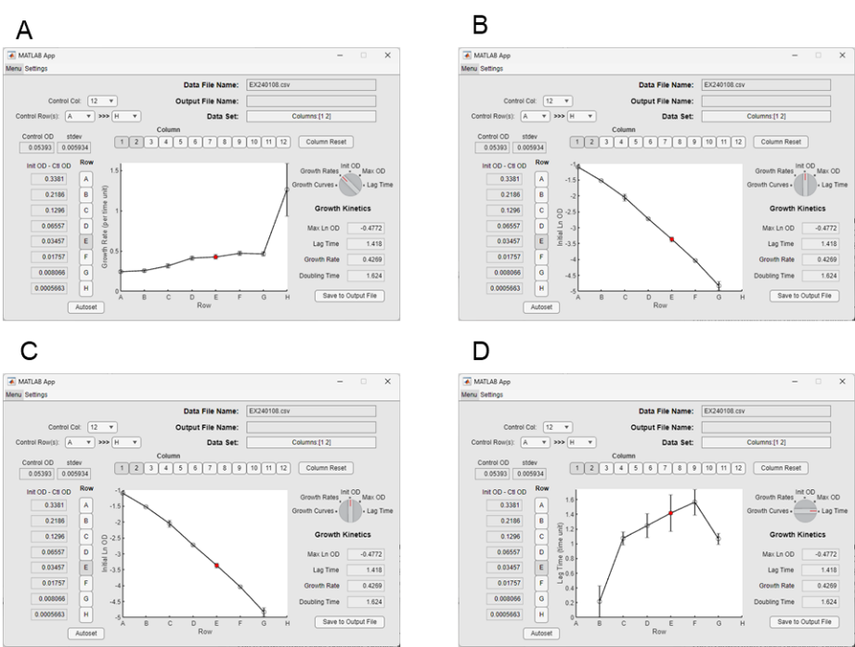

Figure 6. The selector switch to the right of the main graph window may be used to display the effect of different initial OD values on the indicated parameter: Growth Rate (A), Initi OD (B), Max OD (C), Lag Time (D).

In Figure 6D, some row values are not shown in the graph, this is because the data was not available for display due to the calculated lag time being less than or equal to zero, or because there were missing optical density values resulting from the initial OD being at or below the control OD. Since lag time is calculated based on an intercept of the regression line for the growth rate calculation with a line representing the initial OD value, if the initial OD values is not defined no data may be presented.

The user may save the kinetic parameter data for the selected row and columns to a table of growth data using comma delimited spreadsheet file. Data may be saved using the main menu (Menu > Save Growth Parameters to Spreadsheet) or the Save to Output File button below the Growth Kinetics display values. Resetting and/or reselecting columns followed by pressing the Save to Output File button will append the existing spreadsheet file with additional data. An example output file is shown in Figure 7. Mean values for each parameter, along with the standard error, are displayed in columns.

Figure 7. Example output data file, appended with multiple columns.

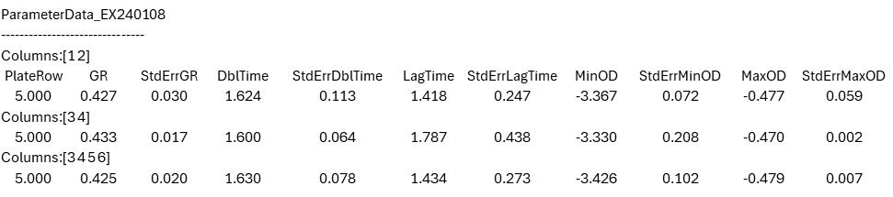

Figure 7. Example comma delimited spreadsheet data generated from three different parameter data sets appended to the same file. The three data sets were from different columns (columns 1,2 and 3,4) along with the final data set (columns 3-6).

The output data (.csv) may be directly imported into a spreadsheet for further formatting and analysis. The selected growth curves may also be exported to a .csv file and used for further analysis in a spreadsheet program (Figure 8).

Figure 8. Example output data for 4 columns

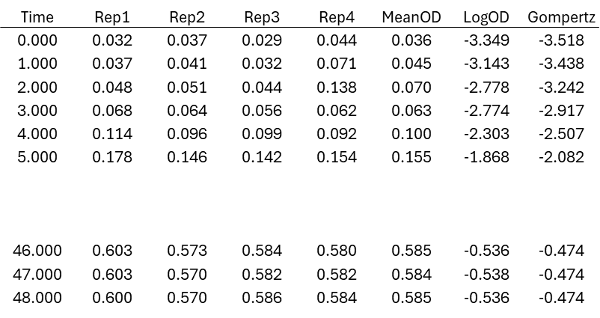

Figure 8. Example output data for growth curves from four columns (listed as replications) along with the meanOD, the natural log transformation of the mean OD and the predicted OD from the Gompertz model.

The optical density output data in the output file is corrected for the background OD and may be used for independent calculations of growth parameters. Once analysis is complete the data file may be closed (Menu > Close All Data), clearing all graph and file data, allowing a new data file to be opened and processed.

The Settings menu opens a dialog box showing three parameters that may be set for data processing with MicroplateGR2 (Figure 9). Adjusting parameters in the settings menu will automatically update the graph and growth curve kinetics as appropriated. Settings indicate 1) the Process-by-N value, which refers to the number of data-points used for the sliding window that is used for the regression algorithm (Breidt et al., 1994); the type of growth curve graph to display, natural log of OD, (‘Y’) or untransformed (‘N’); The minimum OD above background, as discussed above.

Figure 9. The program settings dialog box.

Figure 9. The settings dialog box allows the user to set key processing parameters, including: the number of data-points to use for calculating the regression line used for growth rate determination (Process-by-N value); the type of growth data to display in the growth curve graph (natural log of OD, ‘Y’; untransformed OD, ‘N’); the minimum OD value above background for selecting the appropriate growth curve for generating kinetics parameters (Min OD above background).

The MicroplateGR program, example files and this help file are available for download on the USDA/ARS Food Science Market Quality and Handling Research Unit website. For further information please contact:

Fred Breidt, PhD

*fred.breidt@usda.gov*

USDA/ARS Research Microbiologist,

Food Science and Market Quality

   and Handling Research Unit.

322 Schaub Hall, Box 7624,

NC State University, Raleigh, NC 27695-7624.

Office: 919-513-0186.

[https://www.ars.usda.gov/southeast-area/raleigh-nc/fsmqhru/](https://gcc02.safelinks.protection.outlook.com/?url=https%3A%2F%2Fwww.ars.usda.gov%2Fsoutheast-area%2Fraleigh-nc%2Ffsmqhru%2F&data=05%7C02%7Cfred.breidt%40usda.gov%7C02e4e2004f564c191b6d08dc27e15184%7Ced5b36e701ee4ebc867ee03cfa0d4697%7C1%7C0%7C638429096282378030%7CUnknown%7CTWFpbGZsb3d8eyJWIjoiMC4wLjAwMDAiLCJQIjoiV2luMzIiLCJBTiI6Ik1haWwiLCJXVCI6Mn0%3D%7C0%7C%7C%7C&sdata=utr%2FpYFAzt12q8vtdj9ZTYEHRzQqqy2tRx0231QHgKI%3D&reserved=0)